**LDCW6123 - FUNDAMENTALS OF DIGITAL COMPETENCE FOR PROGRAMMERS**

**GROUP PROJECT**

**Trimester 2, 2023/2024**

**Due date 24 June 2024 (Monday)**

**General information:**

|  |  |  |
| --- | --- | --- |
| Group formation | Group members shall not exceed **5** students per group and must be from the same tutorial section. | |
| Assessment | This group assignment contributes 40% to the total coursework marks. | |
| Student Learning Time | This assignment shall take 18 hours to complete. | |
| Submission requirements | Submission | Submit to respective tutor (softcopy). Submission of the report must be in pdf file.  Only group leaders will make the submission. You will follow your respective tutor submission procedure.  Name your report as: *LDCW6123 Project_student name (student id).pdf*  Example: LDCW6123 Project_Siti Fazariah Hashim (123456789).pdf |
| Cover page | Please use the attached cover page. |
| Group member’s declaration form | Please use the attached form. |
| Assessment rubrics | Included for reference. You do not need to include the rubrics into the report. |

**Mapping of assignment learning outcomes to subject learning outcomes:**

|  |  |  |
| --- | --- | --- |
| **Project Learning Outcomes**  Upon completion of this project, students should be able to: | | **Course Learning Outcomes**  Upon completion of this subject, students should be able to: |
| 1. | Design and develop an online platform that fulfills the website’s objectives. | CLO3: Build a basic interactive program with digital content. |

**Designing and Developing Website and Mobile Apps Prototypes in Collaboration with Git & GitHub**

In this group project of **5**, students will work together to design and develop a semi-functional **website** using Wix.com, create a **mobile apps prototype** using Figma and a **user manual** for that mobile apps using Canva. Each group will collaborate to complete the projects using Git and GitHub.

**Objectives:**

* Understand the key objectives of collaboration tools and software
* Acquire design and development skills through the utilization of Web 3.0 tools.
* Acquire Interface prototyping skills and development through utilization intelligence tools.
* Write a comprehensive user manual to ensure that users can navigate the mobile apps effectively.
* Acquire the skills to collaborate online using Git and GitHub

**Guidelines:**

Select one type of project (listed below) to design and develop. Bear in mind that the features (web pages) listed for each website are essential. Students are required to include other necessary and relevant content as they deem suitable. Create a site map for the website (refer figure 1.0). For the mobile apps, it should support the nature of the chosen project (e.g.: Business, commerce, or blogs):

1. **Business**

Design a convincing narrative to educate potential customers about the enterprise, appealing to them to collaborate with you. The features on the website will include:

* Explanation of the array of services offered.
* Providing a comprehensive overview of the company's background (usually found on the About page).
* Offering essential company details such as address, phone number, and email.
* Outlining the mission statement.

1. **E-commerce**

The purpose of the website is to sell items online. The features will include:

* Gallery with high-quality images.
* Pages that list the products and add to cart function.
* Wishlist of customers.
* Customers’ order invoices.
* Shipping tracking status.

1. **Blogs**

Blogs are developed to educate visitors about current events or specific knowledge scope, such as cooking recipes, fitness or wellness, mental health, etc. The webpages that you will include will feature:

* Article catalogs.
* Sample articles for each category.
* Payment gateways for raising funds or donations.

1. **Portfolio**

Used by professionals to showcase sample works or working experiences to attract future customers. The website will have web pages that include:

* Gallery of quality images of work samples.
* Information about the agency or company.
* Detailed explanation of the services and charges.
* Contact details.

**Deliverables:**

1. Semi-functional website using (Wix.com or any online web builder)
2. Figma mobile apps prototype (Figma)
3. Mobile apps user manual (Canva)
4. Recorded Video presentation
5. Peer Evaluation form
6. Softcopy of activities using Git and GitHub (Git log)

**Submission instructions:**

1. **Group Leader** – To submit all files.
   1. A pdf file consists of (Cover page, table of content, Website url Link, Figma url link & Mobile apps user manual)

*Remark: Please give access to the lecturer to view all collaborative project*

* 1. Recorded presentation video – (all group members must appear in the video)
  2. Own peer evaluation form
  3. A softcopy of the Git Log

1. **Group Member** – To submit individual peer evaluation
2. Peer evaluation form - To evaluate other members, excluding oneself.

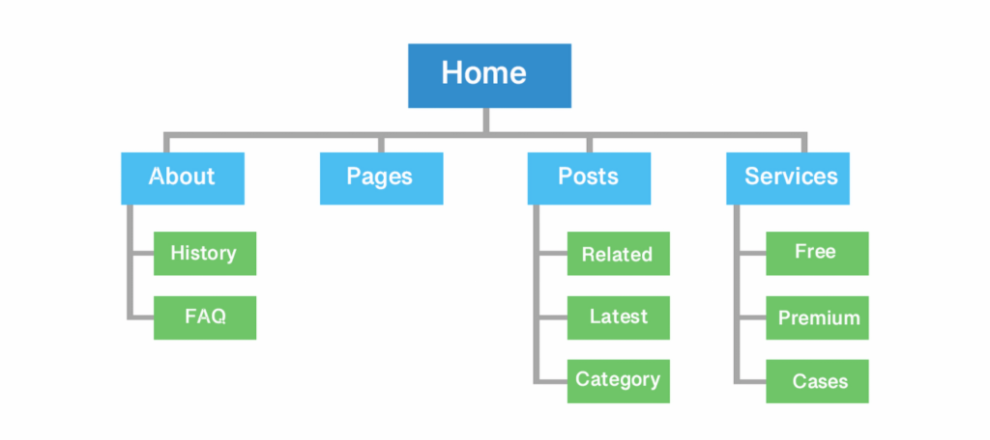

Figure 1.0 : Sample – Website sitemap

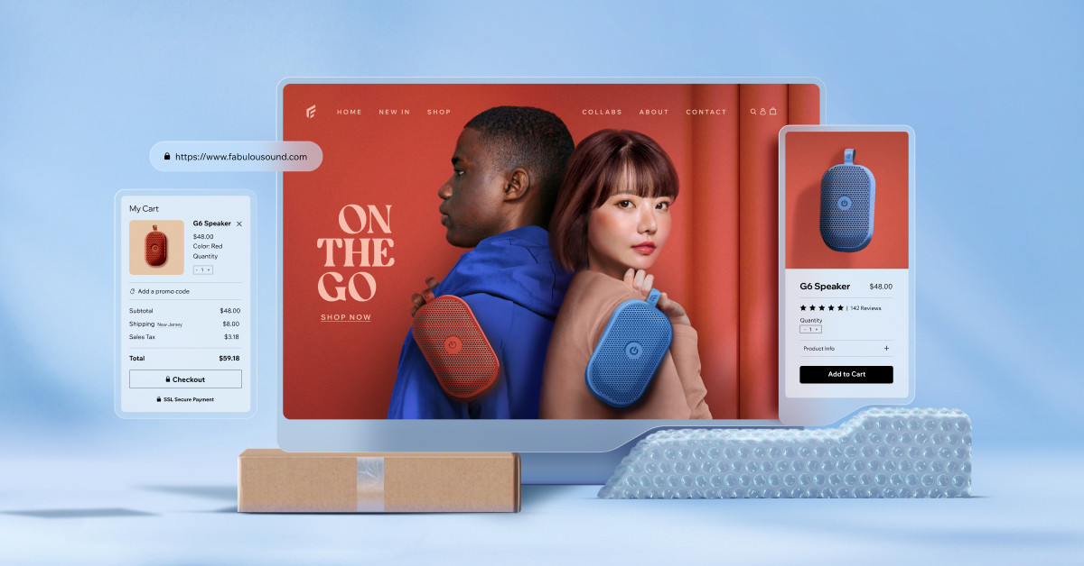

Figure 2.0 : Wix e-commerce website

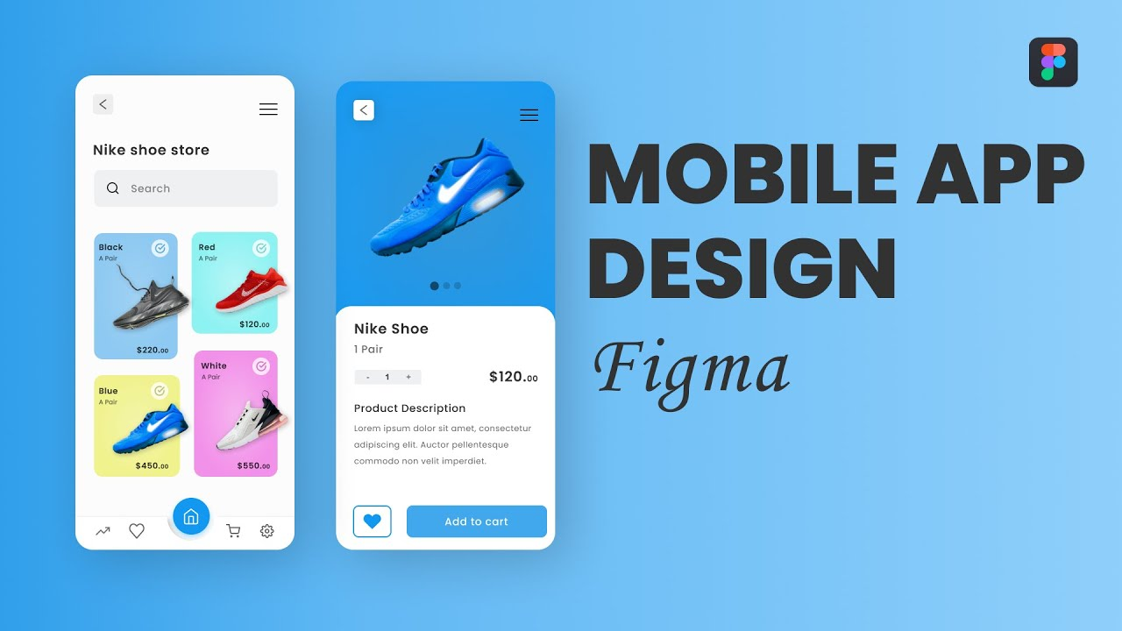

Figure 3.0 : Figma Mobile apps prototype

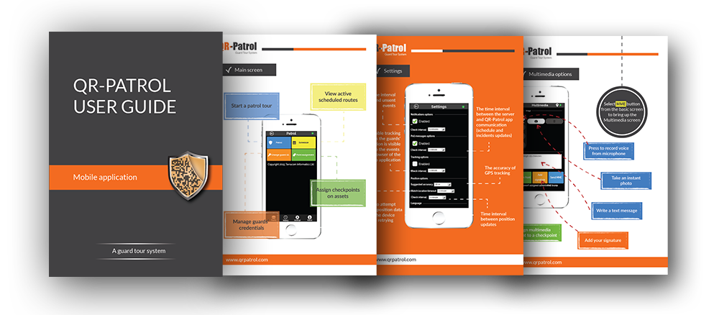

Figure 4.0 : Mobile apps user manual

**Reminders:**

**Plagiarism**

* Plagiarism is a serious offence.
* Plagiarism includes the following behaviors (but not limited to):
  + copy another student’s work.
  + fail to properly cite other people’s work or give proper credit to the original source.
  + using photos, illustrations or online materials downloaded from websites without permission or consent of the original owner of the materials.
  + hire or ask another individual to complete the assignment for you.
  + copy too many words or ideas from one or two sources, that makes up a significant portion of your work, even with proper citations.
* The lecturer has the right not to accept submission of plagiarized or duplicated work.

**Group work**

* Each group member must actively participate in the completion of the assignment. Free riding is unethical and extremely unfair to fellow group members. **Free riders will be awarded zero mark**.
* Should any member be found not contributing to the assignment, the lecturer has the right to change the specific group’s marks to individual marks.
* Each group member is expected to keep the contact numbers and e-mail addresses of the other members of the group.
* The group leader has the responsibility to ensure that all group members play a part in the completion of the assignment. The group leader is also responsible for ensuring that all members’ names are written on the final submission.
* It is the responsibility of each group member to ensure that the final submission is complete and of an acceptable standard. Should any errors or omissions occur in the final submission, each group member is held accountable for negligence – in other words, failure to perform their responsibilities as expected.

**Assessment Rubric**

**Website & Mobile apps prototype evaluation**

|  |  |  |  |  |  |
| --- | --- | --- | --- | --- | --- |
| **Criteria** | Excellent (5) | Good (4) | Satisfactory (3) | Needs Improvement (2) | Inadequate (1) |
| 1. **User Interface & Design (15 marks)** | | | | | |
| * Visual Appeal |  |  |  |  |  |
| * Navigation and Layout |  |  |  |  |  |
| * Consistency in Design Elements |  |  |  |  |  |
| 1. **Functionality & Interactivity (15 marks)** | | | | | |
| * Responsive Design |  |  |  |  |  |
| * Feature Integration |  |  |  |  |  |
| * Cross-browser Compatibility |  |  |  |  |  |
| 1. **Content Quality (15 marks)** | | | | | |
| * Relevance and Accuracy of Information |  |  |  |  |  |
| * Readability and Clarity |  |  |  |  |  |
| * Multimedia Integration |  |  |  |  |  |
| 1. **Accessibility & Inclusivity (15 marks)** | | | | | |
| * Compliance with Accessibility Standards |  |  |  |  |  |
| * Inclusive Design |  |  |  |  |  |
| * Overall Website & prototype performance |  |  |  |  |  |
| **Total (60 marks)** | | | | | |

**Mobile apps user manual**

|  |  |  |
| --- | --- | --- |
| **Section** | **Marks** | **Evaluation Criteria** |
| Introduction | 5 | * Provide brief overview of purpose and functionality. (3 marks) * Outline target audience for the manual. (2 marks) |
| Dashboard Overview | 5 | * Describe main components of user dashboard. (3 marks) * Provide explanation for each feature and its purpose. (2 marks) |
| Navigation Guide | 5 | * Clearly explain website’s main navigation elements. (5 marks) * Include visuals (screenshots or diagrams) to illustrate key features. (5 marks) |
| Functionality Guides | 10 | * Break down each major feature or service offered on the website. (5 marks) * Provide step-by-step instructions on how to use each function. (5 marks) * Encourage users to explore and make the most of the website’s features. (5 marks) |
| Visual Design and Branding | 5 | * Explain the visual elements of the website, such as colour schemes and logos. (5 marks) |
| **Total** | **(30 marks)** |  |

**Git & Git Hub**

|  |  |  |
| --- | --- | --- |
| **Section** | **Marks** | **Evaluation Criteria** |
| Repository Setup | 2 | * Repository setup with a clear name and README |
| Branching and commits | 3 | * Proper use of branches and clear, descriptive commit messages |
| Collaboration | 3 | * Evidence of collaboration through pull requests and discussion |
| Code quality & Documentation | 2 | * Consistent code formatting and readability. * Clear documentation for setup, usage, and contribution guidelines. |
| **TOTAL** | **(10 marks)** |  |

**PROJECT COVER**

|  |  |
| --- | --- |
|  | **LDCW6123 FUNDAMENTALS OF DIGITAL COMPETENCE FOR PROGRAMMERS**  Trimester 2, 2023/2024 |

**GROUP PROJECT**

**Lecturer : ___________________**

**Group: ___________**

*Prepared by:*

|  |  |  |
| --- | --- | --- |
| **Student ID** | **Student Name** | **Phone number** |
|  |  |  |
|  |  |  |
|  |  |  |
|  |  |  |
|  |  |  |

**Declaration by group leader**

I hereby declare that all group members’ names are correctly included in the above section. I hold a copy of this assignment which I can produce if the original is lost or damaged. I certify that no part of this assignment has been copied from any other student’s work or from any other source except where due acknowledgement is made in the assignment.

Group leader’s signature : _____________________________

Group leader’s name : _____________________________

Group leader’s student ID : _____________________________

Date : _____________________________

**Group member declaration**

*(Each group member, including the* ***group leader****, must individually fill up and submit this form)*

Group member’s name : ____________________________

For the purpose of completing this assignment, I have performed the following tasks (please list):

*I hereby declare that I have assessed this submission and I take full responsibility should there be any inaccuracies, incompleteness, omissions, delays or non-submission.*

Group member’s signature : ________________________________

Group member’s name : ________________________________

Group member’s ID : ________________________________

Group member’s tel. no. : ________________________________

Group member’s email : ________________________________

Date : ________________________________

**CONTENT PAGE NO.**

* 1. WEBSITE URL LINK xx
  2. MOBILE APPS URL LINK xx
  3. MOBILE APPS USER MANUAL xx